**USECASE 6**

**Accessing and Using the Azure Portal SOP**

**Go to the Azure Portal:**

Open cloud shell & switch to PowerShell:

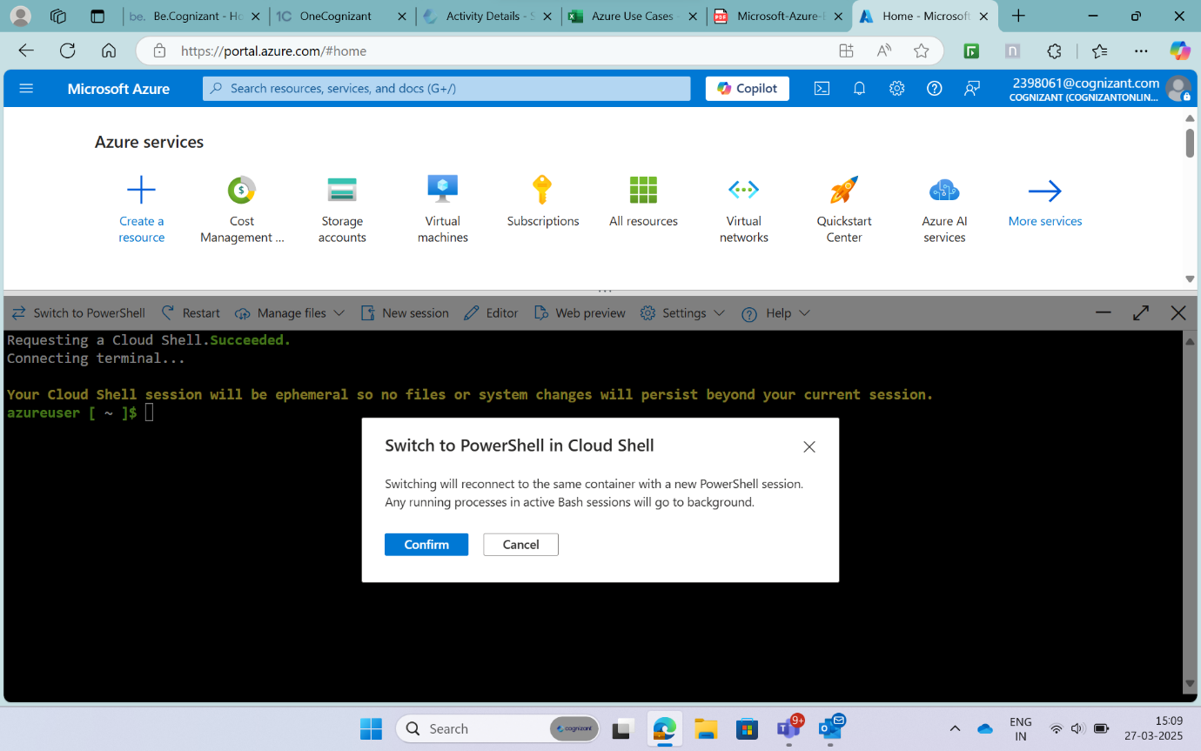

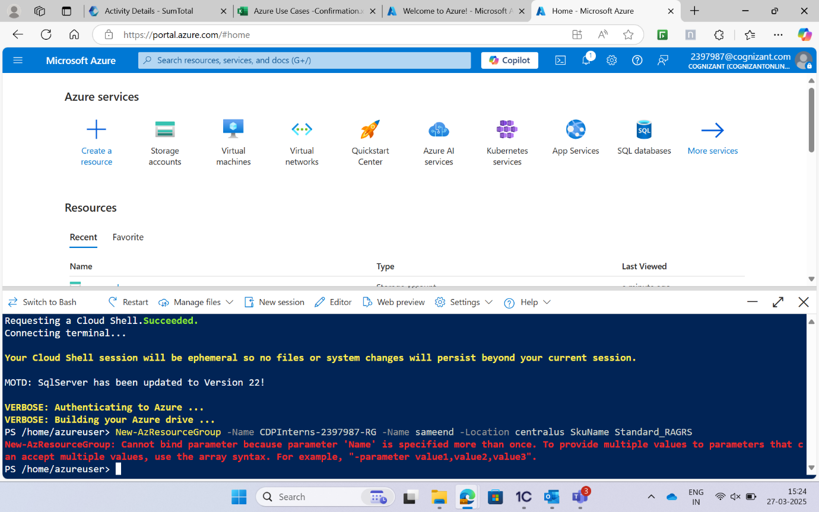

Portal Settings | Directory + Subscription:

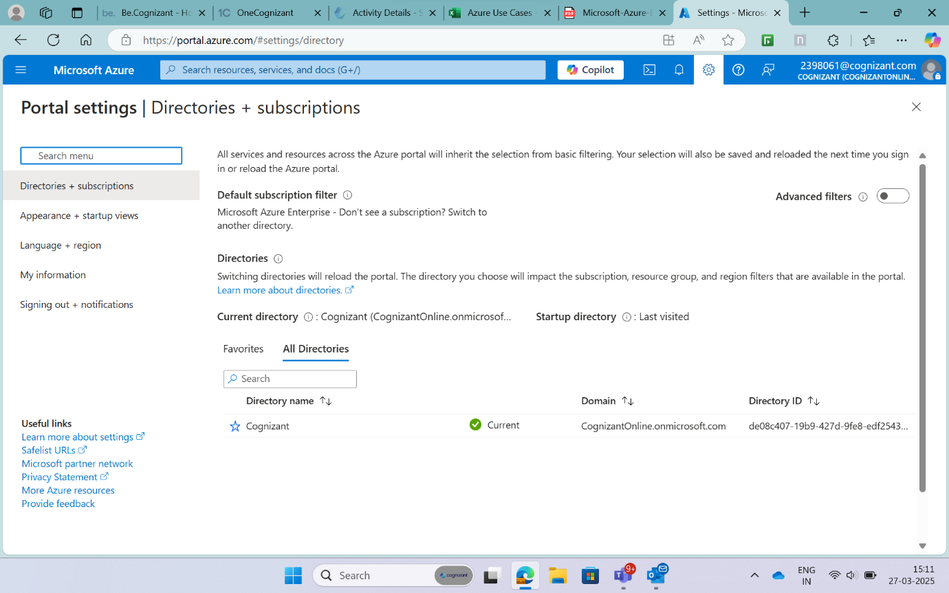

Settings Option lets you change the Theme and Layout for your Azure Account:

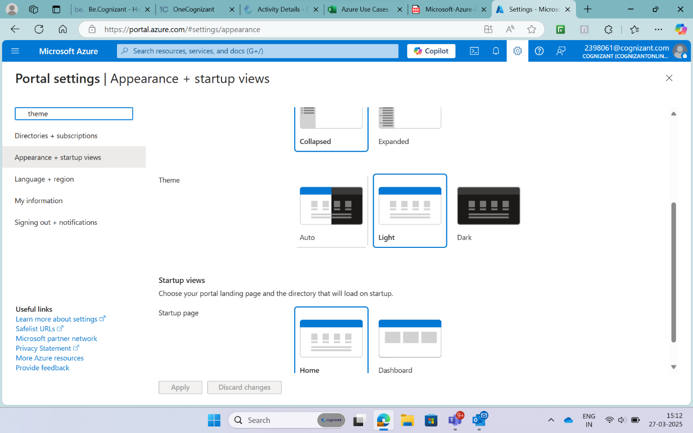

Notifications Icon, Deployment or update is done within Azure:

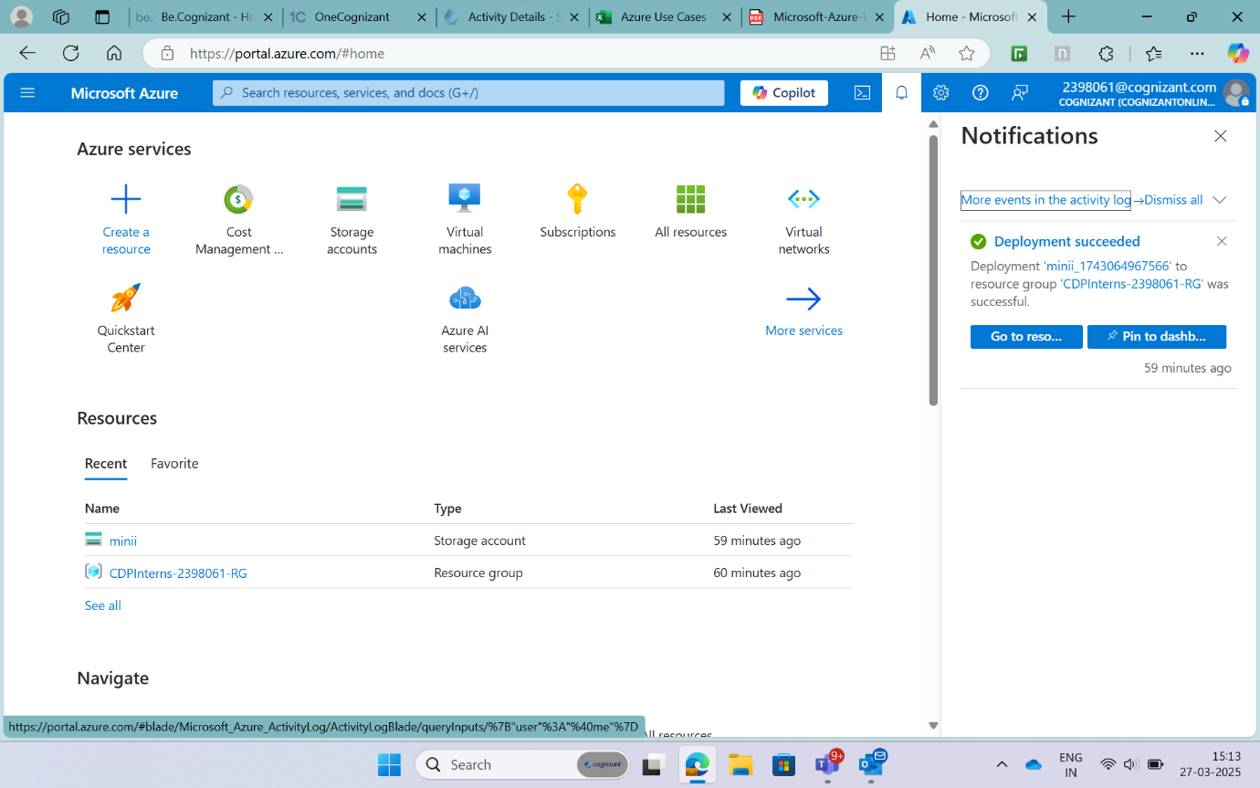

The Question mark icon refers to Help + Support:

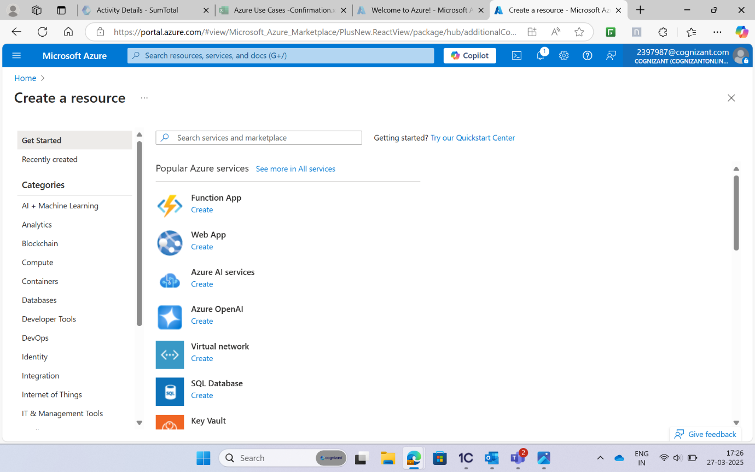

Cost Management + Billing:

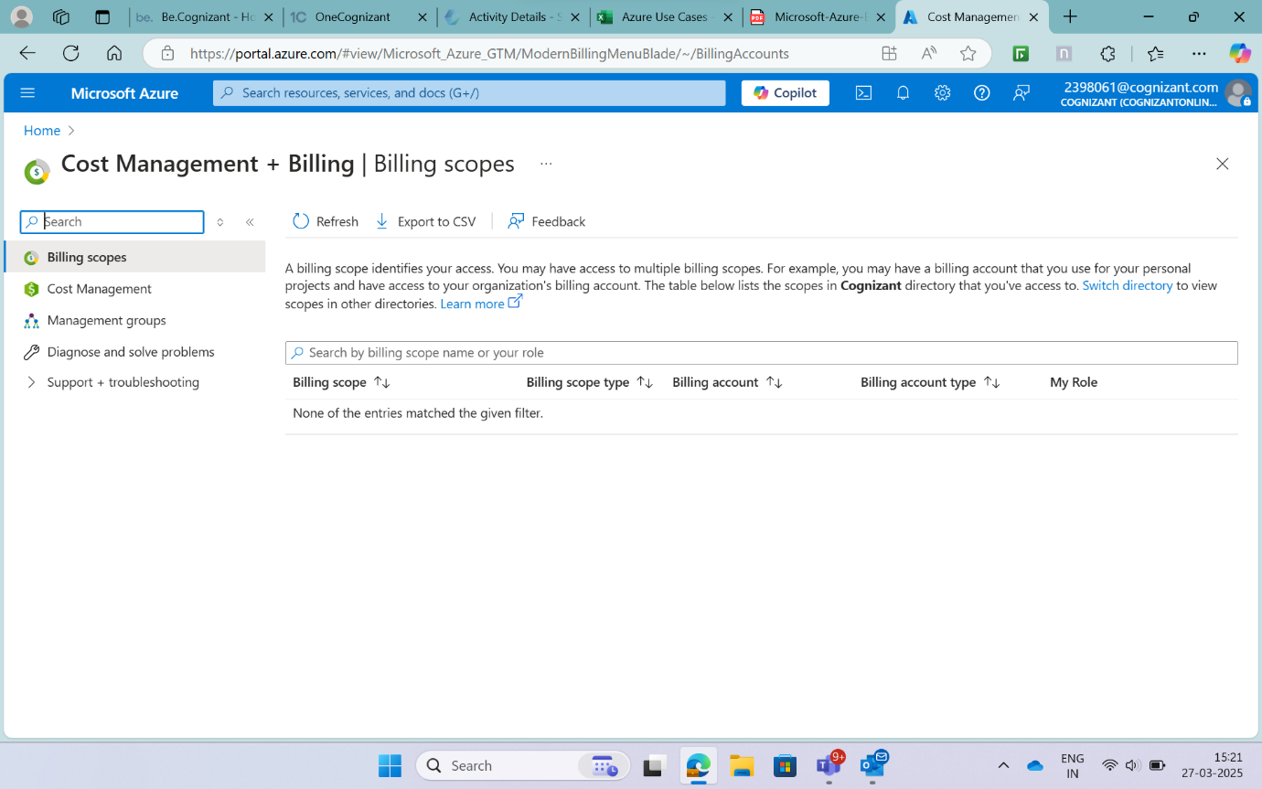

**2. Provision a Virtual Machine from the Portal:**

select Create a resource > Compute > Virtual Machine:



In the Management blade, select Boot diagnostics: Off

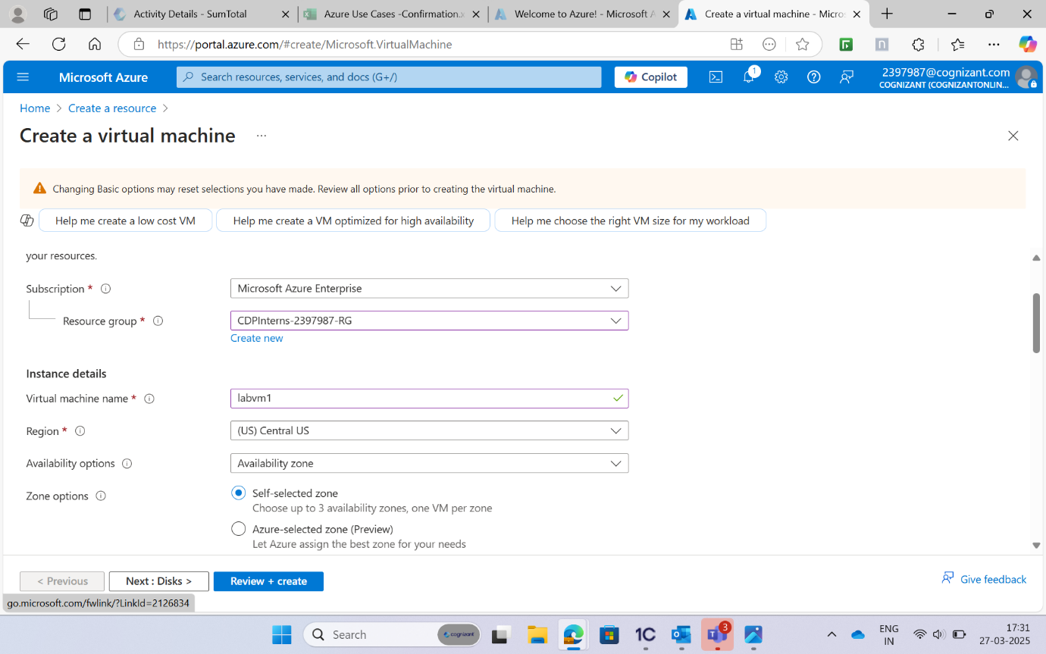

Click Review + Create > Create:

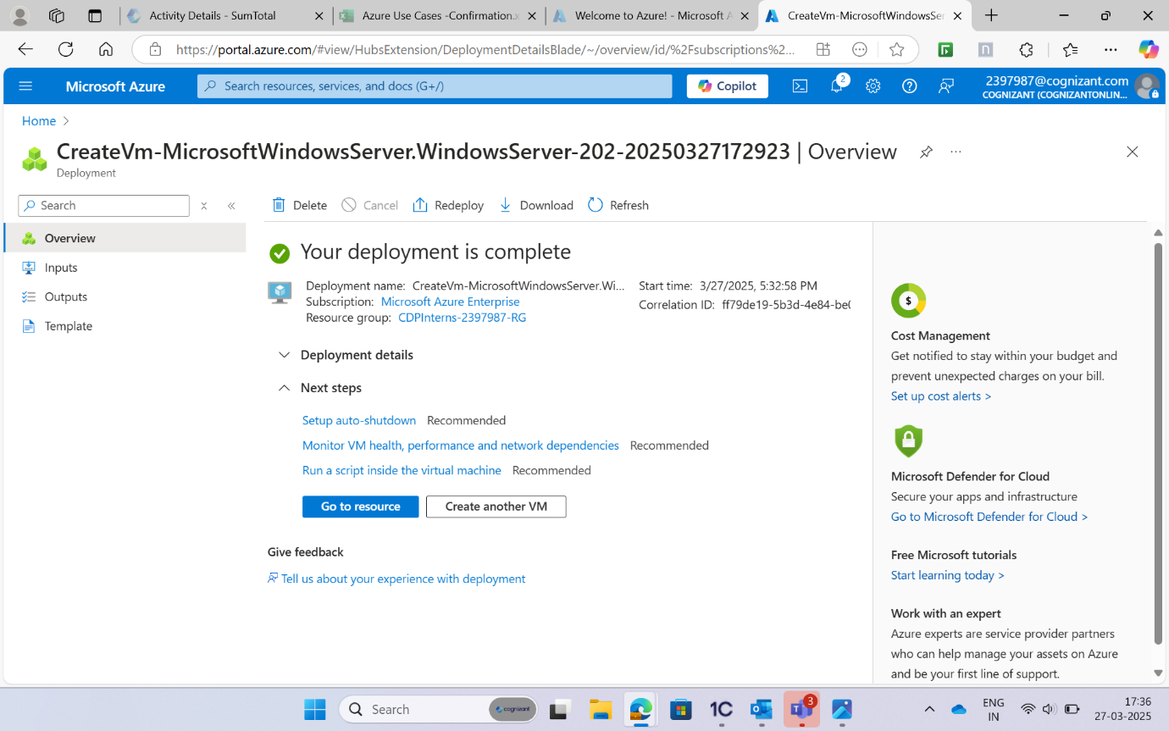

**3. Dashboard Customization:**

Click on New Dashboard:

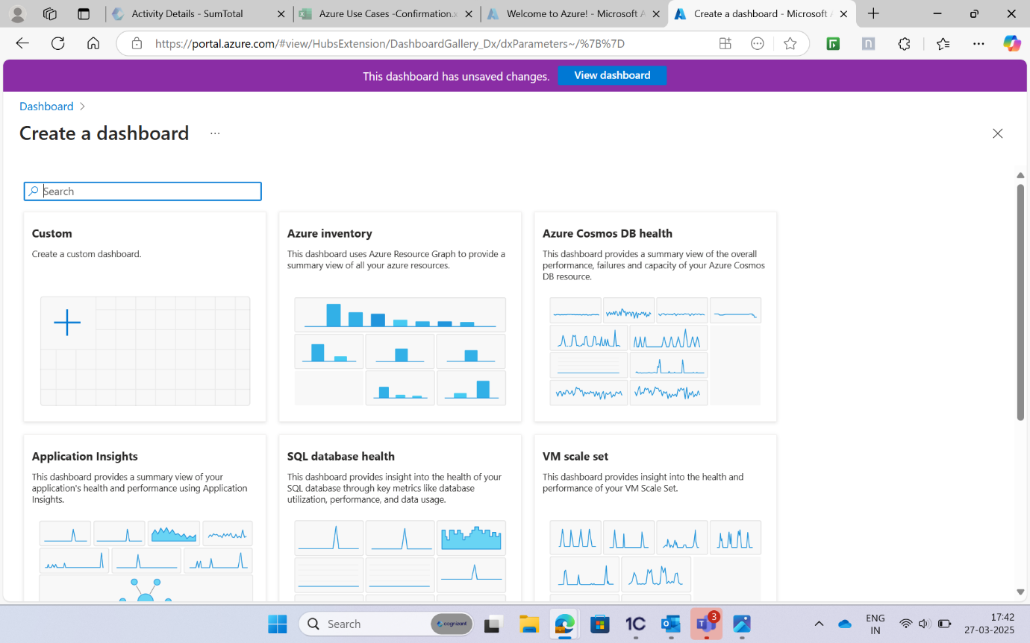

Select the Tiles from the left pane and arrange them:

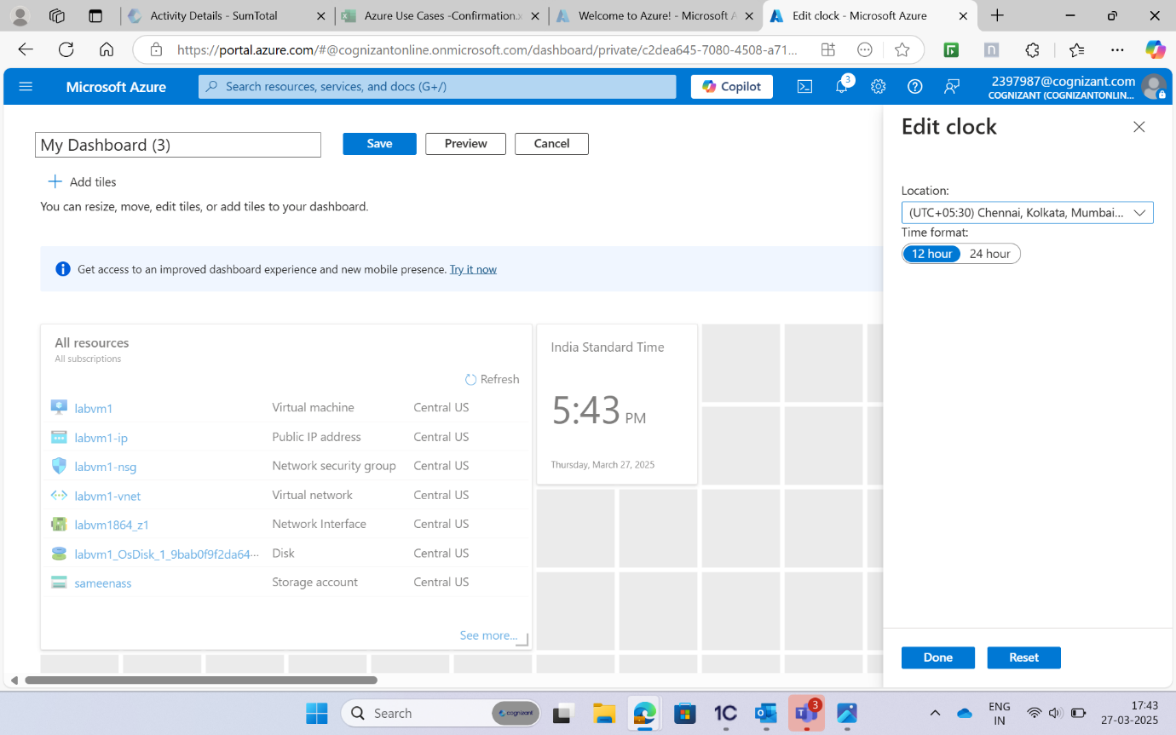

Customized Dashboard is ready to use:

